ZOO WORKSHEET

What was your favorite animal?
________________________________________________________________________________________________________________________________________________

Circle what that animal has

Wings Hooves Antlers Tails
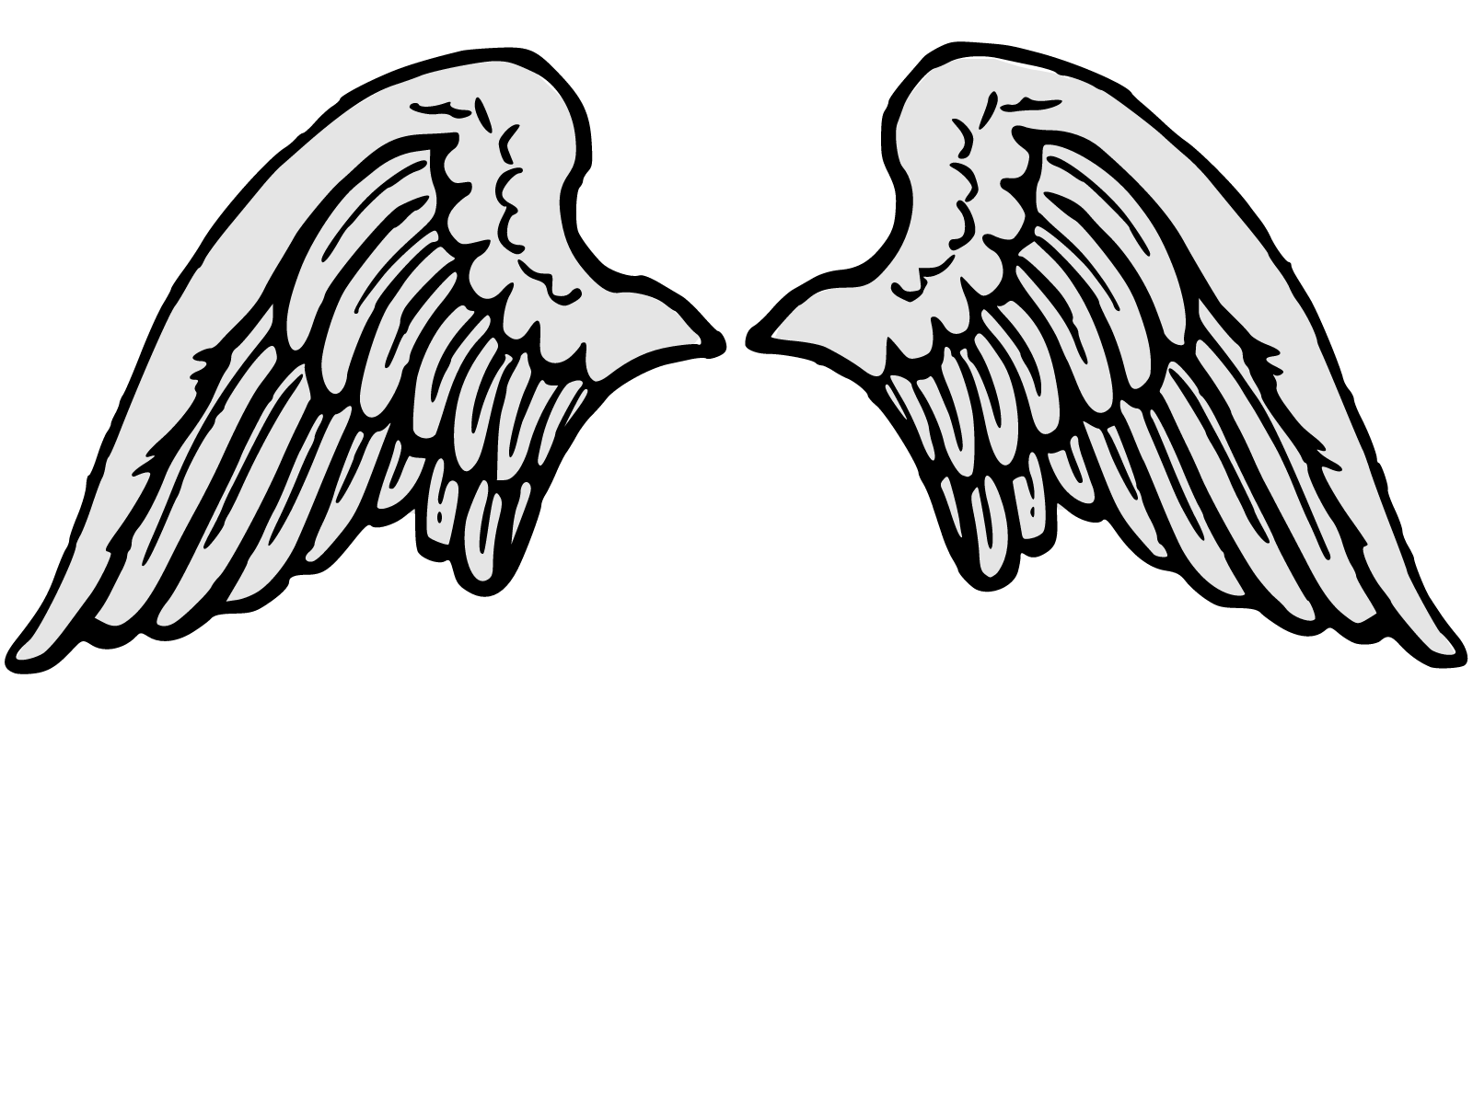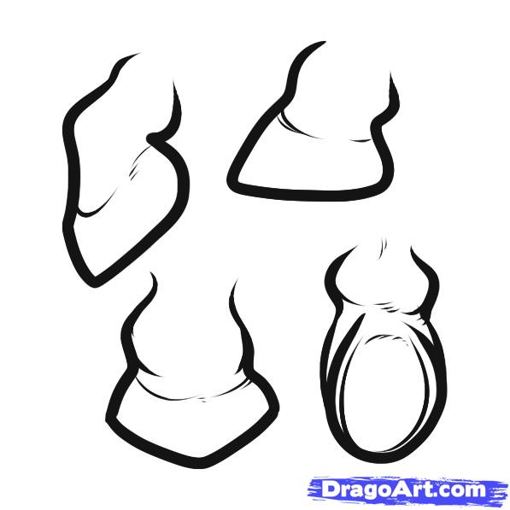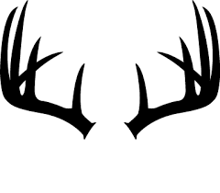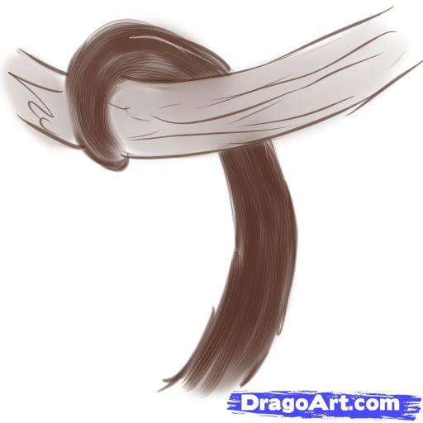

Draw and color a picture of the animal

